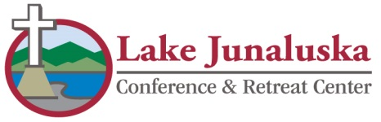 Revised 6/14
CODE OF CONDUCT
Lake Junaluska Conference and Retreat Center

Please take a moment to go over this Code of Conduct with your group. We want you to have a
comfortable, safe, and rewarding visit!

- Lake Junaluska is an alcohol-free, weapon-free and drug-free facility.

- Lake Junaluska provides a “smoke free” environment for all of its guests. Please be courteous of guests
and staff and refrain from smoking in any of our facilities. Smoking is permitted outside.

- Lake Junaluska quiet hours are from 11:00p.m. to 7:00a.m. The Assembly wide curfew begins at
midnight. Please stay indoors after this time.

- Group leaders and counselors are responsible for their group at all times.

- Fireworks are not allowed on Assembly Grounds.

- Open Flame Devices: Due to their risk to life and property, candles, (including decorative, un-burnt wicks, etc.) torches, incense and any other open flame devices are strictly prohibited inside all Lake Junaluska Conference Center Buildings and Hotels.

- Water guns, Super Soakers, water balloons, shaving cream fights, Silly String, etc. will NOT be tolerated
inside any Lake Junaluska facility.

- Please conduct yourself in a manner that shows respect and consideration for fellow guests (i.e. no running
in hallways, playing in elevators, unnecessary horseplay, use of profanity or public displays of affection).

- Roller blades and/or skateboards are allowed in designated areas only. Check with the Front Desk for these areas.

- Sidewalks are provided for pedestrian traffic. Please do not walk in the street.

- Please be prepared to present your meal card or event nametag when entering the dining room. In the event of lost or stolen meal cards, please go to the Front Desk to receive a replacement before entering the dining room.

- When requesting additional keys at the Front Desk, please be prepared to identify yourself. Youth or
children may be requested to return with an adult leader. This is for your own protection.

- Please be advised that you are responsible for any valuables left in your room. Lake Junaluska assumes
no responsibility for lost, stolen or damaged property unless secured in a Hotel safe.

- Groups are requested to provide a credit card at check-in for damages or excessive cleaning. Lake Junaluska
will retain all or part of the $200 damage deposit in the event there is damage to property by your group.

Name of Church ____________________________________________________________________

Contact’s Signature __________________________________________________________________

Date ______________________

